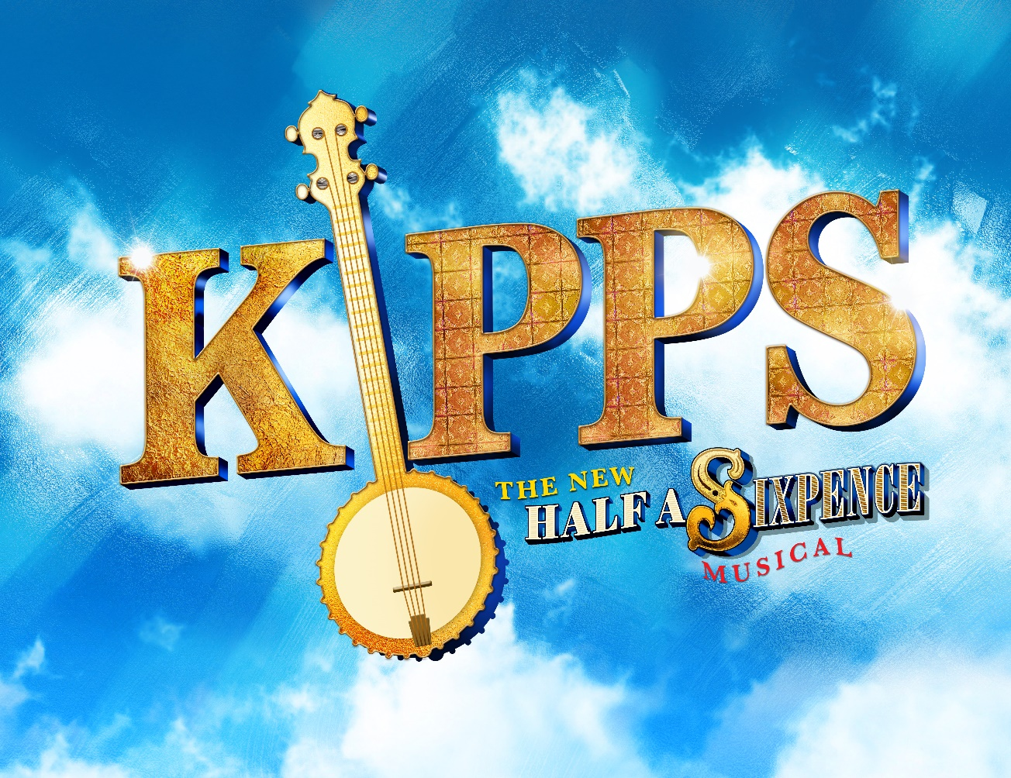

SMTS AUDITION PACK
Directed by Jacky Bacon
MD Liam Fletcher
Choreographer Becky Toward
The Plowright Theatre, March 1st - 4th 2023

Audition date Sunday October 30th
Auditions will take place at
Old Brumby Community Church Hall
The auditions will commence at 10 am.
Individual times will be confirmed at rehearsal.
Synopsis

Arthur Kipps, an orphan, is an over-worked draper’s assistant at Shalford’s Bazaar, Folkestone, at the turn of the last century. He is a charming but ordinary young man who, along with his fellow apprentices, dreams of a better and more fulfilling world, but he likes his fun just like any other. When Kipps unexpectedly inherits a fortune that propels him into high society, he becomes confused about everything he thought he knew about life.
Watching him wrestle with his new identity is his childhood sweetheart, Ann Pornick, who sees with dismay how Arthur is being manipulated by the beautiful and classy Helen Walsingham and her conniving mother and very shady brother James into parting with his new found wealth. Both of these young women love Arthur – there is no doubt about that – but which should he listen to? With the help of his friends, Arthur learns that if you want to have the chance of living the right life, you need to make the right choices.
This is a high energy, fast moving show which revolves around the character of Kipps and all the people he comes into contact with. He is rarely off the stage and has lots of costume changes.
However all the other characters are equally as important to the story and will need to be well developed to highlight the difference in the upper and working classes.
There are some great musical numbers and lots to do for everyone involved.
This new stage version of Half a Sixpence returns to the H. G. Wells semi-autobiographical novel, “Kipps”, in order to reinvent the musical “Half a Sixpence” for the modern age. Julian Fellowes has rewritten the lib with George Stiles and Anthony Drewe as the musical team.

Important dates:

Tuesday September 13th First rehearsal, read/sing through.
Sunday October 30th Auditions
Tuesday September 13th until Tuesday December 20th Rehearsals.
Tuesday November 1st the cast will be announced.
There may also be some principal rehearsals on Thursdays, this will be confirmed after casting.
From Sunday January 8th to Sunday February 19th rehearsals will be every Tuesday and Sunday. A schedule will be provided once casting is completed and attendance at every rehearsal you are called for is vital.
All Tuesday and Sunday rehearsals will be at the church. Any extra rehearsals may be at a different venue, this will be confirmed at a later date.
Sun February 26th Move into the Theatre. All principals to be at the Theatre for Mic fitting and sound checks Sunday evening - time to be confirmed later.
Monday February 27th: Tech rehearsal
Tuesday February 28th: Dress rehearsal
Performances:
1st, 2nd, 3rd March 7.30pm
4th March Matinee 2pm. Evening performance 7.30pm

Character breakdown:
Arthur Kipps An Apprentice at Shalford's Bazaar. A simple soul. Working class, very chirpy and likeable. Will also play Young Arthur.
Ann Pornick Young companion to Arthur, works as a domestic maid, sweet nature, sincere, girl next door, again very likeable. Will also play young Ann.
Aunt Susan Kipps Simple, kindly, working class (Non- singing)
Uncle Bert Kipps Simple, kindly, working class (Non - singing)
Sid Pornick Ann's brother, an Apprentice. Working class, little older than Arthur perhaps, very strong character.
Pierce Apprentice, a bit of a dandy
Buggins Apprentice, a pessimist, worries about everything.
Chitterlow An actor, playwright and impresario. Very charismatic, larger than life character.
Mr Shalford Portly middle aged proprietor of Shalford's bazaar.
Carshot Floor walker at Shalford's bazaar, a bit downtrodden.
Flo Evans Head window dresser at Shalford's bazaar. Nice, chirpy and confident.
Helen Walsingham Educated and classy.
Mrs Walsingham Helen's mother, fussy, self-important and an out and out snob.
James Walsingham Helen's brother, financial adviser, bit of a drip, out to trick Arthur.
Lady Punnet/Ensemble Wealthy friend of Mrs Walsingham.
Mrs Bindo - Botting/Ensemble Well to do friend of Lady Punnet
Lady Dacre/Ensemble Well to do friend of Lady Punnet.
Hayes/Miss Ross /Ensemble Students at Helen's woodworking class.
Foster /Ensemble Lady Punnet's Butler.
Mr Maxwell/Ensemble An architect.
Mary/ Ensemble Sid's fiancée.
Photographer/Ensemble Male (Bari-Tenor)
Ensemble Shoppers, Crowd, Party Guests, Policeman, Waiters, Posh Ladies and Gentlemen, Wedding party guests, Maids etc.

Music Audition pieces

Arthur Kipps No 6 She's too far Above Me - whole song
No 14 If the Rain's got to fall - Beginning to Bar 43 (including whistling)
No 19 In the middle there's me - Beginning to bar 43
No 20 Long ago - Whole song
Ann Pornick No 10 Long Ago - Whole song
No 17 I never get anything right - Beginning to bar 24
No 20 Long ago - Whole song
Shalford No 3 Look alive- Bar 20 - 35
Chitterlow No 11 The Joy of the Theatre - Beginning to bar 47
Sid/Pierce/Buggins No 3 Look alive - Bar 43-106 (Sing all parts)
Carshot No 3 Look alive - Bar 43-106 (Sing all parts)
Helen No 5 Believe in Yourself - Beginning to bar 23
James No 10b A Simple Lunch - Beginning to bar 18
Flo No 13 Just a Little Touch of Happiness - Whole song
Photographer No 21 Beginning to Bar 28 (Including opening dialogue, sing Kipps line as well
Mrs Walsingham No 18 Bar 3-26 Sing both parts
Lady Punnett No 16 Bar 17-47
Mrs Bindo Botting No 16 Bar 17-47

Dialogue Audition parts:
Arthur Kipps Page 16-17 up to Song
Page 21-23 up to 'Money? What? For me?'
Page 100-101 up to 'Thank You God'
Ann Pornick Page 40-42 up to 'Your Wish is my command'
Page 100-101 up to 'Thank you God'
Aunt Susan Page 37-38 (Read both parts)
Uncle Bert Page 37-38 (Read both parts)
Mr Shalford Page 8-10
Chitterlow Page 21-23
Sid Page 86-88
Pierce Page 11-12 (Read Pierce and Buggins)
Buggins Page 11-12 (Read Pierce and Buggins)
Helen Page 18 from 'I've always noticed you' to Page 19 'See you next term'
James Page 35-36
Flo Page 60-61 'I've seen you giggle at them'
Mrs Walsingham Page 53-54
Lady Punnet Page 66-67
Mrs Bindo-Botting Page 66-67
Lady Dacre Page 66-67
All other parts will be cast from Auditionees.
Please do your best to try and learn the parts for the auditions, even if you need a book in your hand for security. It doesn't matter if you're not word perfect it is the characterisation we need to see. The reader in will prompt you. Read the whole script to get an understanding of the character and where they fit into the story not just the audition pieces. How do they relate to the other characters? Are they upper or lower class, a snob, innocent, cheeky, feisty etc.? How are they feeling at this point in the story? Kipps in particular needs to portray a huge range of emotions throughout the show.
If you have any questions please do not hesitate to ask me. Each person may audition for two parts in total but will be considered for other parts if unsuccessful, please let us know if there is anything you would not wish to be considered for.
Jacky 07813802289

Kipps Audition information

The Auditions will take place on Sunday 30 October at Old Brumby United Church commencing at 10pm.

The show dates are weekend commencing Sunday 26 February to Saturday 4 March 2023.

The auditions will take place in the order in which they are listed. If you wish to audition please complete an audition form at rehearsal and hand it in to me no later than the start of rehearsal on Tuesday 25 October so that I can compile a list of the people auditioning.

Subscriptions are due from the date of the AGM and must be paid no later than Tuesday 25 October or you will not be allowed to take part in the auditions.

I would encourage you to try for two parts as it gives the audition panel more options.

The audition panel will consist of Jacky Bacon - Director, Liam Fletcher - Musical Director and Duane Tow assistant MD

Jake West will read in at the auditions.

It is your choice whether you sing or do the dialogue first and there will also be a short movement/dance audition. Please do not be put off by this, we are looking for potential not professional dancing ability!

Rehearsals will take place every Tuesday evening up until Christmas. We may start blocking some numbers before Christmas as there is a lot to do in this show. After Christmas there will also be Sunday rehearsals and perhaps some Thursdays too.

Please ensure that if you are auditioning for a role that you will be available for rehearsals. A rehearsal schedule will be available once the show is cast and it will be useful if you can let us know in advance of any dates that you may not be available for. Commitment to rehearsals is vital!

There may be times when you are unable to attend through illness or work commitments. It is then your duty to inform the director or the MD before the rehearsal begins and to arrange for someone to take notes to help you catch up with any chorus movement you may have missed.

Contact details will be added to the bottom of the rehearsal schedule.

Any questions please feel free to contact me. Kipps is a high energy, fast moving, fun show and I’m looking forward to directing it. I'm sure Liam will be available to help with the audition music but we will go through it all at rehearsals too.

SMTS Kipps Audition form

Name …………………………………………………………………………………………...

Telephone …………………………………………………………………………………………..

Email …………………………………………………………………………………………..

Characters auditioning for .......................................................................................................

……………………………………………………………………..

I wish to be considered for any other part. Please indicate by circling either: Yes No

Dates you may be unavailable ………………………………………………………………………..

…………………………………………………………………………

Please return to me by Tuesday October 25th

Thank you

Jacky
07813802289

